**PROGRAMING THE FOOD ORDERING SYSTEM-**



DESCRIPTION OF THE PROJECT:

The mini project, “Food ordering system”, which is built using c language  
which has the functionality of selecting your preferred restaurant, Ordering food items from the menu’s of the respective restaurant which can later be paid through several methods (or) ways of payment with ease. The user is given a multiple number of options they can go through while ordering their hunger wishes.

***ALGORITHM***

Step 1: Start  
Step 2 : declare function firstpage()  
Step 3: print the topic and decorations  
Step 4: declare function res_list()  
Step 5: declare the variable c1  
Step 6: declare switch cases if case is 1 print the restaurant names if case is 0 break and go to res_list function  
Step 7: declare function userdetails()  
Step 8: display “Please fill in your delivery details”  
Step 9: declare variables

* fname
* lname
* pn
* a1
* a2
* t1
* lm
* pc

Step 10: print and scan the following details

* First name
* Last name
* Phone number
* Address lane one
* Address lane two
* Town / locality
* Landmark
* Pin code

Step 11: declare function res1()

Step 12: declare the following variables

* ch
* i
* qty
* initialise net=0

Step 13: display “WELCOME TO RESTAURANT 1!” and “MENU” and display the menu

Step 14: display “enter your choice “ and display all the items chosen by the user

Step 15: for next item in menu display “If you want to select one more item press 1 or else 0” if the user presses 1 go to menu

Step 16: if user presses 0 display user details for them to enter and display the total amount pay

Step 17: display “payment options available for you” and display the option “UPI Pay with CARD Cancel order”

(REPEAT THE SAME FOR ALL THE OTHER RESTAUANTS)

Step 18: enter the following function in switch case

* for case 1 upi()
* for case 2 card()
* for case 3 display “Your order is cancelled”
* for any other cases display “invalid choices

(REPEAT THE SAME FOR ALL THE OTHER RESTAUANTS)

Step 19: declare the function upi() and declare the following function in upi

* un
* pw

display “UPI PAYMENT” ,“ENTER USERNAME”,”ENTER PASSWORD” if password and username is correct display “Successful LOGIN” if wrong details are entered display “Wrong Credentials, Please try again”

Step 20: declare the function card() and declare the following function in card

* nc
* cn
* ch4
* month
* yr

display “PAY WITH CARD”, “NAME ON CARD” , “CARD NUMBER” , “Valid Through:” , “Type yes to confirm your order and no to cancel” if all the credentials are correct and presses yes display “Your order is placed” or else order is cancelled

Step 21: declare function confirmation() and and declare variable confirm and display “Type yes to confirm payment and no to cancel order” if yes then check with bank and display “PAYMENT SUCCESSFUL!!” if no then display “ORDER CANCELLED <ANY ATM OF MONET DEBITED WILL BE REFUNDED WITHIN 9 DAYS!”

Step 22: declare function cod() , declare variable ch5 and ask to type yes to confirm order or no to cancel the order if yes is given then display “Your order is placed!” if no then display “order cancelled!”

Step 23: declare function main and assign variable i=0 and display “Current date and time:” and declare all the functions used in the code and display “THAK YOU !! VISIT US AGAIN!”

**Pseudocode:**\*start  
*Declare a function called firstpage()  
 Print the following statements;  
 “Restaurant Mini Project”  
 “WELCOME”  
 “[0]exit continue[1]”  
 “Enter your choice:”

*Declare a function called option()  
 Print ”Cash on delivery is only available for orders pricing below Rs.500!”

*Declare a function called thankyou()  
 Print “THANK YOU!! VISIT US AGAIN!!”

*Declare a function called res_list()  
 Declare the int data type variable, c1;  
 get the input for the variable c1;  
 Create a switch case statement for c1;  
 In case 1: print the list of restaurants  
 In case 0: Call the thankyou() function  
 In default case: print “Invalid choice”

*Declare a function called userdetails()  
 Declare the following char variables;  
 fname[25],lname[25],pn[25],a1[2500],t1[50],lm[50],pc[50];  
 Print the following statement and get the input for each statement from the   
 user.  
 “First name:”  
 “Last name:”  
 “Phone No.:”  
 “Address Line:”  
 “Town/Locality:”  
 “Landmark:”  
 “Pincode:”  
 Assign the user inputs to each of the variables.  
*Declare a new function called res1()  
 Declare the int variables: ch,i,qty,net=0.  
 Print the Menu of the restaurant along with its name.  
 Declare a lable called repeat:  
 under this lable print “Enter your choice:”  
 get the input from the user and assign it to the ch variable.  
 Create a switch case statement for ch.  
 Print the product name for each case and also print ”Enter the quantity:” and get the input to assign it to the qty variable under each cases.  
 Calculate the net total at the end of each case and store it in the variable net. The formula is, net+=(qty*price_of_food_item);  
 Print ”If u want to select one more item press 1 else press 0:”  
 Get the value of the input and assign it to i.  
 Create an If else condition, where if i=1 go to the repeat lable.  
 Else Print the total amount.  
 Print The payment options which are UPI, PAY WITH CARD and CASH ON DELIVERY.  
 Create an If else condition that,If the net total is greater than 500 do not display the Cash on delivery option . Else print all the options.  
Create a lable called chagain:  
 Under this LABLE:  
 Print the statement ”Enter your choice:” and get the input from the user.  
 Assign this value to the variable a, and create a switch case for a.  
 Case 1: Calls the upi() function.  
 Case 2: Calls the card() function.  
 Case 3: Calls the cod() function (If net<500)  
 Case 4: Print(“Your Order is cancelled”)(Choice of cancellation)  
 default case: print (“Invalid choice”) and go to the lable chagain.  
*Declare 3 more functions called as res2(),res3() and res4(), and repeat the same   
 process of res1().  
*Declare a new function called food()  
 Declare a new variable called c2.  
 Print “Select a restaurant:” and get the input from the user and assign it to the c2 variable.  
 Create a switch case statement for c2 and under each cases call the function for each of the restaurants. In the default case, print “Invalid Choice”.  
*Declare a function called upi()  
 Declare two new character variables called pw and un.   
 Create a lable called tryagain:  
 Under this lable print the statements to get the username and password from the user, and assign them to the variables un and pw.  
 By using string compare operator, compare the strings with the existing username and password.  
 Existing usernames and passwords are,  
 Username Passwords  
 1. vinoth vinothnas  
 2. surya surya2314  
 3. sayak sayak123  
 4. santhosh san777  
 5. Yazhini yazhini23  
 6. Taranalakshmi taranalakshmi46

If the inputs are true print “Login successful”, else go to the lable tryagain.  
*Declare a new function called card()  
 declare 5 variables called nc,cn,ch4,vt,cvv;  
 Print the required statements to get the card details of the user and assign it to the respective variables.  
*Declare a new function called as confirmation()  
 Declare a char type variable called confirm.  
 Print a statement to get the user’s input as yes or no.  
 Assign the input to the variable confirm, and compare it with yes and no using the strcmp operator.  
 Create an if else condition, such as if input = “yes” print payment succesfull.  
 Else print Order cancelled. And call the thankyou() function.  
*Declare another fun called cod()  
 Declare a variable called ch5.  
 Print a statement to get the input from the user as yes or no, and assign it to the variable ch5.Create an if else condition for ch5, such as if ch5 = yes, print “Your order is placed” else print “Your order is cancelled”.  
*Declare the main() function.  
 Declare t as a time data type to get the current time and date from the system and print it.  
 Call the following functions in the following order:  
 1)firstpage();  
 2)res_list();  
 3)food();  
*Compile and Run the program.

**Flowcharts:**

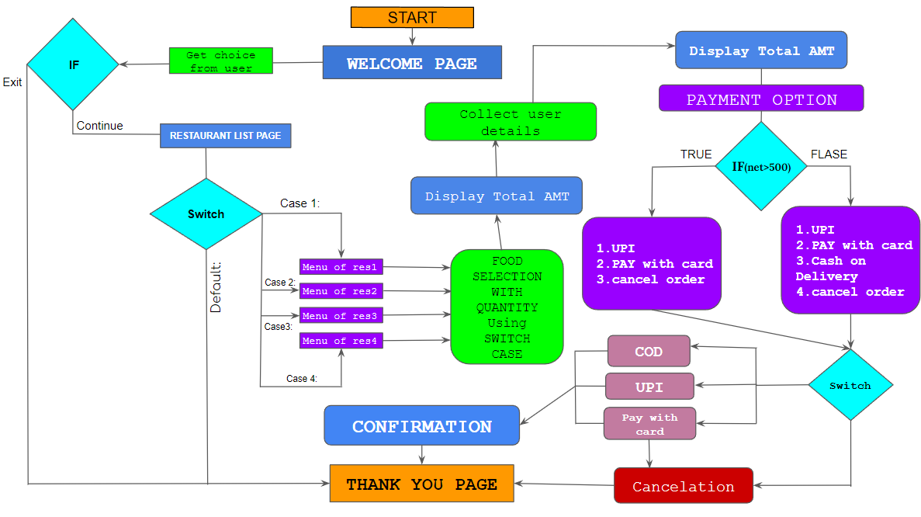

**SOURCE CODE:**

#include<stdio.h>  
#include<windows.h>  
#define clrscr() system("cls")

void firstpage()

{

printf("**************************************\n");

printf(" RESTAURANT MINI PROJECT");

printf("\n !! FOODDADY !!");

printf("\n\n WELCOME \n");

printf("\n[0]Exit Continue[1]\n");

printf("\n**************************************\n");

printf("Enter your choice:");

return 0;

}

void options()

{

printf("\nCash on delivery is only available for orders pricing below Rs.500!");

}

void thankyou()

{

printf("\n\n\tTHANK YOU!! VISIT US AGAIN!!\n");

for(int i=0;i<100;i++) printf("X");

}

int res_list()

{

int c1;

scanf("%d",&c1);

clrscr();

switch(c1)

{

case 1:

{

printf("LIST OF RESTAURANTS:\n");

printf("1.SAI VIHAR\n");

printf("2.RASIKAS\n");

printf("3.11 TO 11\n");

printf("4.SARAVANA BHAVAN\n");

break;

}

case 0:

thankyou();

break;

default:

printf("\nInvalid choice");

break;

}

}

void userdetails()

{

printf("Please fill in your delivery details \n");

char fname[25],lname[25],pn[25],a1[2500],tl[50],lm[50],pc[50];

printf(" First name :\t");

scanf("%s",&fname);

printf(" Last name :\t");

scanf("%s",&lname);

printf(" Phone No. :\t");

scanf("%s",&pn);

printf("Address Line :\t");

scanf("%s",&a1);

printf("Town/Locality :\t");

scanf("%s",&tl);

printf("Landmark :\t");

scanf("%s",&lm);

printf("Pincode :\t");

scanf("%s",&pc);

printf("\n");

for(int l=0;l<80;l++) printf("X");

int a;

}

int res1()

{

int ch,i,qty,net=0;

printf("\n\n WELCOME TO SAI VIHAR! ");

printf("\n***********MENU CARD***********");

printf("\n1)PONGAL (V) Rs:70");

printf("\n2)POORI (V) Rs:65");

printf("\n3)VADAI (V) Rs:25");

printf("\n4)PAPER ROAST DOSA(V) Rs:55");

printf("\n5)CHAPATI (V) Rs:65");

printf("\n6)ONION UTTAPAM (V) Rs:99");

printf("\n7)TEA (V) Rs:45");

printf("\n8)IDLI(3 Pcs) (V) Rs:60");

printf("\n*******************************");

repeat:

printf("\n Enter Your choice : ");

scanf("%d",&ch);

switch(ch)

{

case 1:

printf("\nYou have selected :PONGAL");

printf("\nEnter The Qty : ");

scanf("%d",&qty);

net=net+(qty*70);

break;

case 2:

printf("\nYou have selected :POORI");

printf("\nEnter The Qty : ");

scanf("%d",&qty);

net+=(qty*65);

break;

case 3:

printf("\nYou have selected :VADAI");

printf("\nEnter The Qty : ");

scanf("%d",&qty);

net+=(qty*25);

break;

case 4:

printf("\nYou have selected :PAPER ROAST DOSA");

printf("\nEnter The Qty : ");

scanf("%d",&qty);

net+=(qty*55);

break;

case 5:

printf("\nYou have selected :CHAPATI");

printf("\nEnter The Qty : ");

scanf("%d",&qty);

net+=(qty*65);

break;

case 6:

printf("\nYou have selected :ONION UTTAPAM");

printf("\nEnter The Qty : ");

scanf("%d",&qty);

net+=(qty*99);

break;

case 7:

printf("\nYou have selected :TEA");

printf("\nEnter The Qty : ");

scanf("%d",&qty);

net+=(qty*45);

break;

case 8:

printf("\nYou have selected : IDLI(3 Pcs)");

printf("\nEnter The Qty : ");

scanf("%d",&qty);

net+=(qty*60);

break;

default:

printf("\nInvalid Product Selection\n");

break;

}

printf("If you want to select one more item press(1) else press (0): ");

scanf("%d",&i);

if(i==1){

goto repeat;

}

else

{

printf("Total amount = Rs.%d/-",net);

Sleep(3000);

clrscr();

userdetails();

int a;

printf("\nTOTAL AMOUNT TO BE PAID : \tRs.%d/-\n",net);

for(int l=0;l<80;l++) printf("X");

printf("\nPAYMENT OPTIONS AVAILABLE for YOU!:-");

options();

if(net>500)

{

Sleep(500);

printf("\n1.UPI\n2.Pay with CARD\n3.Cancel order");

chagain:

printf("\nEnter your choice\t:");

scanf("%d",&a);

switch(a){

case 1:

upi();

break;

case 2:

card();

break;

case 3:

printf("\n\tYour order is cancelled!");

thankyou();

break;

default:

printf("\n\tINVALID CHOICE");

goto chagain;

break;

}

}

else

{

printf("\n1.UPI\n2.Pay with CARD\n3.Cash on Delivery\n4.Cancel Order");

chagain1:

printf("\nEnter your choice:\t");

scanf("%d",&a);

switch(a){

case 1:

upi();

break;

case 2:

card();

break;

case 3:

cod();

break;

case 4:

printf("\n\tYour order is cancelled!");

thankyou();

break;

default:

printf("\n\tINVALID CHOICE");

goto chagain1;

break;

}

}

}

}

int res2()

{

int ch,i,qty,net=0;

printf("\n\n WELCOME TO RASIKAS! ");

printf("\n*************MENU CARD*************");

printf("\n1)CHICKEN BIRIYANI (N) Rs:260");

printf("\n2)BUTTER NAAN (V) Rs:52");

printf("\n3)GRILLED CHICKEN (N) Rs:250");

printf("\n4)PANEER BUTTER MASALA(V) Rs:120");

printf("\n5)MUTTON MASALA (N) Rs:364");

printf("\n6)PRAWN CURRY (N) Rs:312");

printf("\n7)MUSHROOM CHETTINADU (V) Rs:182");

printf("\n8)DAL TADKA (V) Rs:182");

printf("\n***********************************");

repeat:

printf("\n Enter Your choice : ");

scanf("%d",&ch);

switch(ch)

{

case 1:

printf("\nYou have selected : CHICKEN BIRIYANI");

printf("\nEnter The Qty : ");

scanf("%d",&qty);

net=net+(qty*260);

break;

case 2:

printf("\nYou have selected : BUTTER NAAN");

printf("\nEnter The Qty : ");

scanf("%d",&qty);

net+=(qty*52);

break;

case 3:

printf("\nYou have selected : GRILLED CHICKEN");

printf("\nEnter The Qty : ");

scanf("%d",&qty);

net+=(qty*250);

break;

case 4:

printf("\nYou have selected : PANEER BUTTER MASALA");

printf("\nEnter The Qty : ");

scanf("%d",&qty);

net+=(qty*120);

break;

case 5:

printf("\nYou have selected : MUTTON MASALA");

printf("\nEnter The Qty : ");

scanf("%d",&qty);

net+=(qty*364);

break;

case 6:

printf("\nYou have selected : PRAWN CURRY");

printf("\nEnter The Qty : ");

scanf("%d",&qty);

net+=(qty*312);

break;

case 7:

printf("\nYou have selected : MUSHROOM CHETTINAD");

printf("\nEnter The Qty : ");

scanf("%d",&qty);

net+=(qty*182);

break;

case 8:

printf("\nYou have selected : DAL TADKA");

printf("\nEnter The Qty : ");

scanf("%d",&qty);

net+=(qty*182);

break;

default:

printf("\nInvalid Product Selection\n");

break;

}

printf("If you want to select one more item press(1) else press (0): ");

scanf("%d",&i);

if(i==1){

goto repeat;

}

else

{

printf("Total amount = Rs.%d/-",net);

Sleep(3000);

clrscr();

userdetails();

int a;

printf("\nTOTAL AMOUNT TO BE PAID :\tRs.%d/-\n",net);

for(int l=0;l<80;l++) printf("X");

printf("\nPAYMENT OPTIONS AVAILABLE for YOU!:-");

options();

if(net>500)

{

printf("\n1.UPI\n2.Pay with CARD\n3.Cancel order");

chagain:

printf("\nEnter your choice\t:");

scanf("%d",&a);

switch(a){

case 1:

upi();

break;

case 2:

card();

break;

case 3:

printf("\n\tYour order is cancelled!");

thankyou();

break;

default:

printf("\n\tINVALID CHOICE");

goto chagain;

break;

}

}

else

{printf("\n1.UPI\n2.Pay with CARD\n3.Cash on Delivery\n4.Cancel Order");

chagain1:

printf("\nEnter your choice:\t");

scanf("%d",&a);

switch(a){

case 1:

upi();

break;

case 2:

card();

break;

case 3:

cod();

break;

case 4:

printf("Your order is cancelled!");

thankyou();

break;

default:

printf("INVALID CHOICE");

goto chagain1;

break;

}

}

}

}

int res3()

{

int ch,i,qty,net=0;

printf("\n\n WELCOME TO 11 TO 11! ");

printf("\n*************MENU CARD*************");

printf("\n1)VEG GRILLED SANDWICH (V) Rs:45");

printf("\n2)BPQ PANEER SHAWARMA (V) Rs:105");

printf("\n3)8' VEG SPICY PIZZA (V) Rs:140");

printf("\n4)VEG SPICY WRAP (V) Rs:80");

printf("\n5)CHILLI CHEESE BURGER (V) Rs:85");

printf("\n6)BROWNIE MILK SHAKE (V) Rs:100");

printf("\n7)RED VELVET MILK SHAKE(V) Rs:95");

printf("\n8)KITKAT MILK SHAKE (V) Rs:95");

printf("\n***********************************");

repeat:

printf("\n Enter Your choice : ");

scanf("%d",&ch);

switch(ch)

{

case 1:

printf("\nYou have selected : VEG GRILLED SANDWICH");

printf("\nEnter The Qty : ");

scanf("%d",&qty);

net=net+(qty*45);

break;

case 2:

printf("\nYou have selected : BPQ PANEER SHAWARMA");

printf("\nEnter The Qty : ");

scanf("%d",&qty);

net+=(qty*105);

break;

case 3:

printf("\nYou have selected : 8' VEG SPICY PIZZA");

printf("\nEnter The Qty : ");

scanf("%d",&qty);

net+=(qty*140);

break;

case 4:

printf("\nYou have selected : VEG SPICY WRAP");

printf("\nEnter The Qty : ");

scanf("%d",&qty);

net+=(qty*80);

break;

case 5:

printf("\nYou have selected : CHILLI CHEESE BURGER");

printf("\nEnter The Qty : ");

scanf("%d",&qty);

net+=(qty*85);

break;

case 6:

printf("\nYou have selected : BROWNIE MILK SHAKE");

printf("\nEnter The Qty : ");

scanf("%d",&qty);

net+=(qty*100);

break;

case 7:

printf("\nYou have selected : RED VELVET MILK SHAKE");

printf("\nEnter The Qty : ");

scanf("%d",&qty);

net+=(qty*95);

break;

case 8:

printf("\nYou have selected : KITKAT MILK SHAKE ");

printf("\nEnter The Qty : ");

scanf("%d",&qty);

net+=(qty*95);

break;

default:

printf("\nInvalid Product Selection\n");

break;

}

printf("If you want to select one more item press(1) else press (0): ");

scanf("%d",&i);

if(i==1){

goto repeat;

}

else

{

printf("Total amount = Rs.%d/-",net);

Sleep(3000);

clrscr();

userdetails();

int a;

printf("\nTOTAL AMOUNT TO BE PAID :\tRs.%d/-\n",net);

for(int l=0;l<80;l++) printf("X");

printf("\nPAYMENT OPTIONS AVAILABLE for YOU!:-");

options();

if(net>500)

{

printf("\n1.UPI\n2.Pay with CARD\n3.Cancel order");

chagain:

printf("\nEnter your choice:\t");

scanf("%d",&a);

switch(a){

case 1:

upi();

break;

case 2:

card();

break;

case 3:

printf("Your order is cancelled!");

thankyou();

break;

default:

printf("INVALID CHOICE");

goto chagain;

break;

}

}

else

{printf("\n1.UPI\n2.Pay with CARD\n3.Cash on Delivery\n4.Cancel Order");

chagain1:

printf("\nEnter your choice:\t");

scanf("%d",&a);

switch(a){

case 1:

upi();

break;

case 2:

card();

break;

case 3:

cod();

break;

case 4:

printf("Your order is cancelled!");

thankyou();

break;

default:

printf("INVALID CHOICE");

goto chagain1;

break;

}

}

}

}

int res4()

{

int ch,i,qty,net=0;

printf("\n\n WELCOME TO SARAVANA BHAVAN! ");

printf("\n***********MENU CARD***********");

printf("\n1)PAROTTA[2 Pcs] (V) Rs:50");

printf("\n2)PANEER FRIED RICE (V) Rs:149");

printf("\n3)GOBI MANCHURIAN (V) Rs:189");

printf("\n4)MUSHROOM CHILLI (V) Rs:179");

printf("\n5)CHICKEN HOT PEPPER(N) Rs:249");

printf("\n6)FISH CURRY (N) Rs:299");

printf("\n7)CRAB FRY (N) Rs:430");

printf("\n8)CHOCOLATE ICECREAM(N) Rs:79");

printf("\n*******************************");

repeat:

printf("\n Enter Your choice : ");

scanf("%d",&ch);

switch(ch)

{

case 1:

printf("\nYou have selected : PAROTTA[2 Pcs]");

printf("\nEnter The Qty : ");

scanf("%d",&qty);

net=net+(qty*50);

break;

case 2:

printf("\nYou have selected : PANEER FRIED RICE");

printf("\nEnter The Qty : ");

scanf("%d",&qty);

net+=(qty*149);

break;

case 3:

printf("\nYou have selected : GOBI MANCHURIAN ");

printf("\nEnter The Qty : ");

scanf("%d",&qty);

net+=(qty*189);

break;

case 4:

printf("\nYou have selected : MUSHROOM CHILLI");

printf("\nEnter The Qty : ");

scanf("%d",&qty);

net+=(qty*179);

break;

case 5:

printf("\nYou have selected : CHICKEN HOT PEPPER");

printf("\nEnter The Qty : ");

scanf("%d",&qty);

net+=(qty*249);

break;

case 6:

printf("\nYou have selected : FISH CURRY");

printf("\nEnter The Qty : ");

scanf("%d",&qty);

net+=(qty*299);

break;

case 7:

printf("\nYou have selected : CRAB FRY");

printf("\nEnter The Qty : ");

scanf("%d",&qty);

net+=(qty*430);

break;

case 8:

printf("\nYou have selected : CHOCOLATE ICECREAM");

printf("\nEnter The Qty : ");

scanf("%d",&qty);

net+=(qty*79);

break;

default:

printf("\nInvalid Product Selection\n");

break;

}

printf("If you want to select one more item press(1) else press (0): ");

scanf("%d",&i);

if(i==1){

goto repeat;

}

else

{

printf("Total amount = Rs.%d/-",net);

Sleep(3000);

clrscr();

userdetails();

int a;

printf("\nTOTAL AMOUNT TO BE PAID :\tRs.%d/-\n",net);

for(int l=0;l<80;l++) printf("X");

printf("\nPAYMENT OPTIONS AVAILABLE for YOU!:-");

options();

if(net>500)

{

printf("\n1.UPI\n2.Pay with CARD\n3.Cancel order");

chagain:

printf("\nEnter your choice:\t");

scanf("%d",&a);

switch(a){

case 1:

upi();

break;

case 2:

card();

break;

case 3:

printf("Your order is cancelled!");

thankyou();

break;

default:

printf("INVALID CHOICE");

goto chagain;

break;

}

}

else

{printf("\n1.UPI\n2.Pay with CARD\n3.Cash on Delivery\n4.Cancel Order");

chagain1:

printf("\nEnter your choice:\t");

scanf("%d",&a);

switch(a){

case 1:

upi();

break;

case 2:

card();

break;

case 3:

cod();

break;

case 4:

printf("Your order is cancelled!");

thankyou();

break;

default:

printf("INVALID CHOICE");

goto chagain1;

break;

}

}

}

}

int food()

{

int c2;

printf("\nSelect a Restaurant :");

scanf("%d",&c2);

switch(c2)

{

case 1:

{res1();

break;}

case 2:

{res2();

break;}

case 3:

{res3();

break;}

case 4:

{res4();

break;}

case 0:

thankyou();

break;

default:

printf("Invalid choice");

break;

}

}

void upi()

{

char un[25],pw[25]; //USERNAMES AND PASSWORDS

tryagain:

for(int i=0;i<80;i++){printf("-");}

printf("\t\nUPI PAYMENT");

printf("\nEnter USERNAME:");

scanf("%s",&un);

printf("\nEnter PASSWORD:");

scanf("%s",&pw);

if(strcmp(un,"vinoth")==0 && strcmp(pw,"vinothnas")==0)

{

printf("\nChecking...");

Sleep(1000);

printf("...");

Sleep(1000);

printf("\nSuccessful LOGIN!!");

confirmation();

}

else if(strcmp(un,"surya")==0 && strcmp(pw,"surya2314")==0)

{

printf("\nChecking...");

Sleep(1000);

printf("...");

Sleep(1000);

printf("\nSuccessful LOGIN!!");

confirmation();

}

else if(strcmp(un,"sayak")==0 && strcmp(pw,"sayak123")==0)

{printf("\nChecking...");

Sleep(1000);

printf("...");

Sleep(1000);

printf("\nSuccessful LOGIN!!");

confirmation();

}

else if(strcmp(un,"santhosh")==0 && strcmp(pw,"san777")==0)

{printf("\nChecking...");

Sleep(1000);

printf("...");

Sleep(1000);

printf("\nSuccessful LOGIN!!");

confirmation();

}

else if(strcmp(un,"yazhini")==0 && strcmp(pw,"yazhini23")==0)

{printf("\nChecking...");

Sleep(1000);

printf("...");

Sleep(1000);

printf("\nSuccessful LOGIN!!");

confirmation();

}

else if(strcmp(un,"taranalakshmi")==0 && strcmp(pw,"taranalakshmi46")==0)

{printf("\nChecking...");

Sleep(1000);

printf("...");

Sleep(1000);

printf("\nSuccessful LOGIN!!");

confirmation();

}

else{

printf("\nWrong Credentials, Please try again\n");

goto tryagain;

}

}

void card()

{

char nc[50],cn[50],ch4[5],vt[25],cvv[3];

for(int i=0;i<80;i++){printf("X");}

printf("\n\tPAY WITH CARD");

printf("\nNAME ON CARD\t:");

scanf("%s",&nc);

printf("\nCARD NUMBER\t:");

scanf("%s",&cn);

printf("\nValid thorugh\t:");

scanf ("%s",&vt);

printf("\nEnter your 3 digit cvv\t:");

scanf("%s",&cvv);

printf("\nType [yes] to confirm order or [no] to cancel the order : ");

scanf("%s",&ch4);

if(strcmp(ch4,"yes")==0){printf("Your order is placed!");thankyou();}

else {printf("%d","your order have been cancelled!");thankyou();}

}

void confirmation()

{

char confirm[5];

printf("\nType 'yes' to Confirm payment and 'no' to cancel order \t:");

scanf("%s",&confirm);

if(strcmp(confirm,"yes")==0)

{

printf("\nCHECKING WITH BANK..");

Sleep(1000);

printf("\n...");

printf("\nPAYMENT SUCCESSFULL!!");

}

else

printf("\nORDER CANCELLED, ANY AMT OF MONEY DEBITED WILL BE REFUNDED WITHIN 9 DAYS!");

thankyou();

}

void cod()

{

char ch5[25];

printf("\nType [yes] to confirm order or [no] to cancel the order : ");

scanf("%s",&ch5);

if(strcmp(ch5,"yes")==0){printf("\n\nYour order is placed!");}

else {printf("%d","\n\nyour order have been cancelled!");thankyou();}

}

void main()

{

time_t t;

time(&t);

int i=0;

clrscr();

printf("\nCurrent date and time : %s",ctime(&t));

firstpage();

res_list();

food();

return 0;

}

**SCREENSHOTS:**

**Selections of Restaurants and Food Items:**

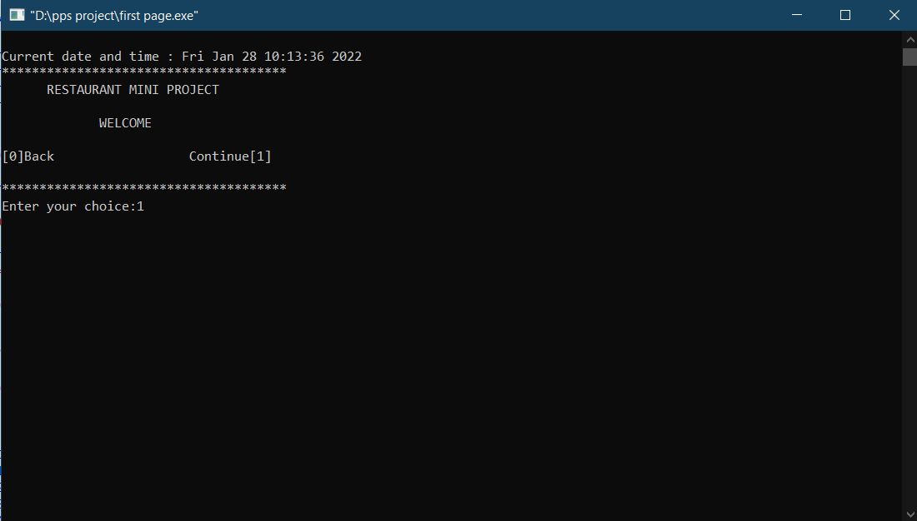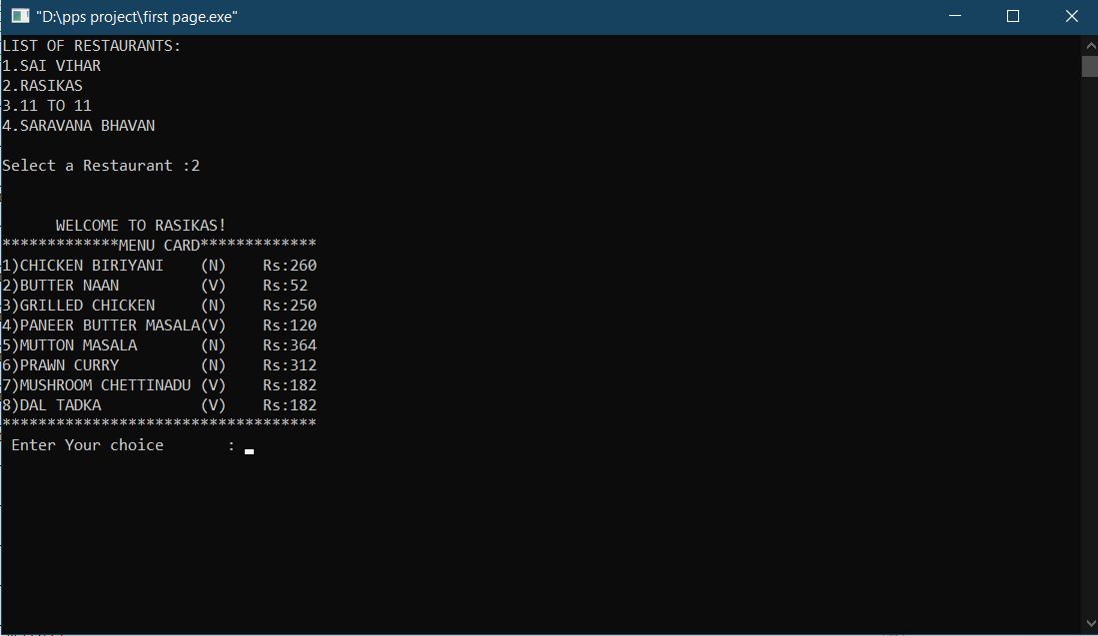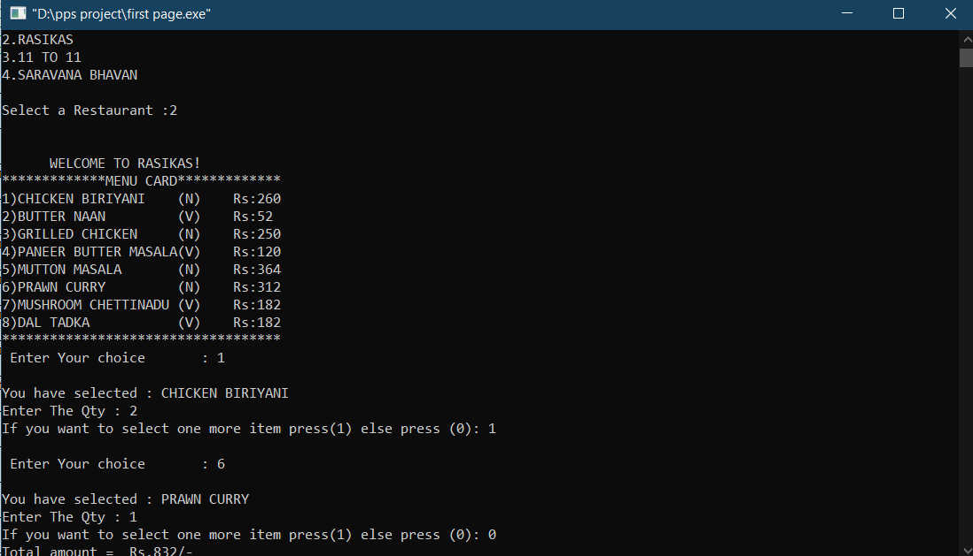

**USER DETAILS AND PAYMENT:-**

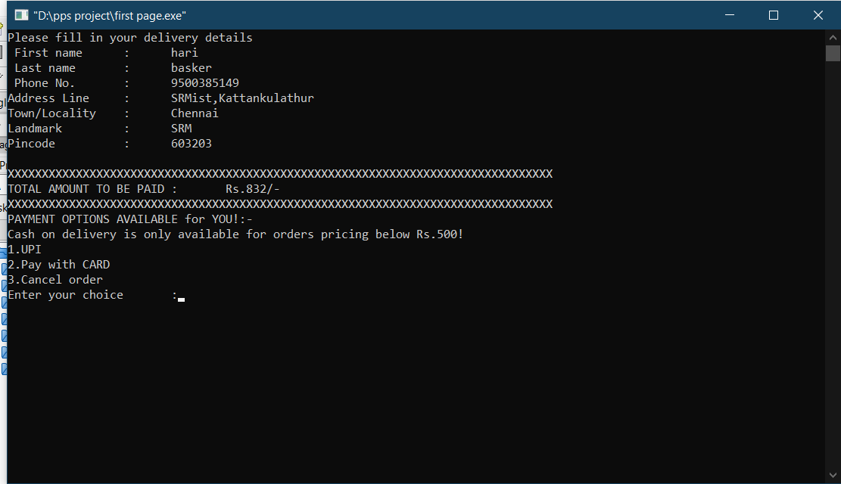

**PAY WITH CARD:-**

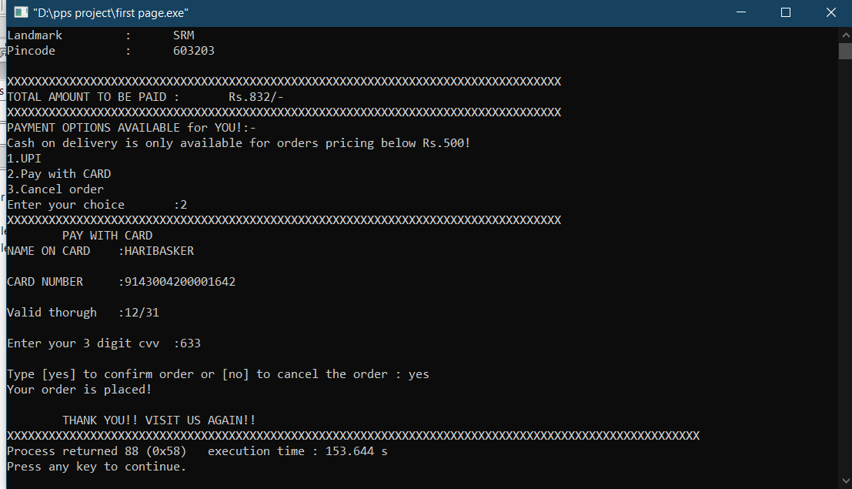

**UPI:-**

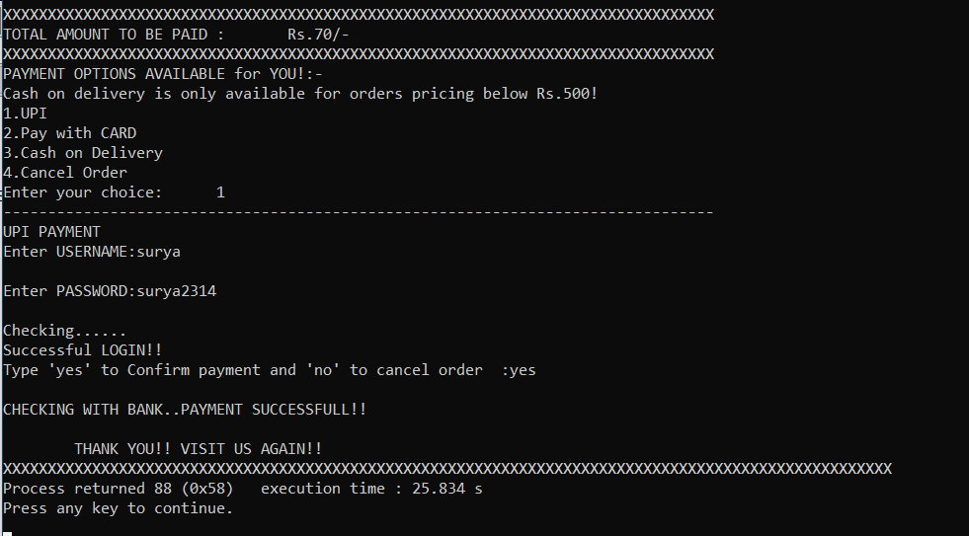

**CASH ON DELIVERY:-**

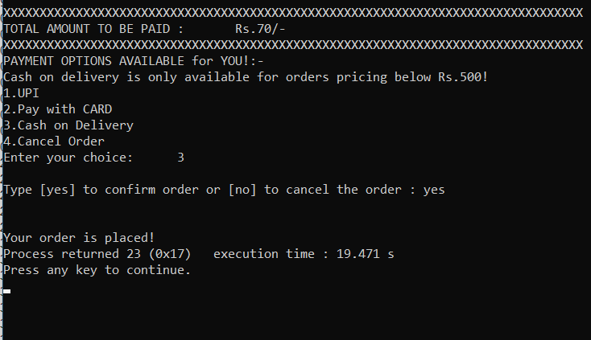

**\*\*\*THANK YOU\*\*\***